A.1
CREATE DATABASE JuniorCollegeDB;
USE JuniorCollegeDB;

CREATE TABLE Student (
StudentID INT PRIMARY KEY,
StudentName VARCHAR(50),
Age INT,
Course VARCHAR(30),
City VARCHAR(30),
Marks INT,
Email VARCHAR(60)
);

INSERT INTO Student (StudentID, StudentName, Age, Course, City, Marks, Email) VALUES
(1, 'Aarav Shah', 18, 'BSc IT', 'Mumbai', 85, 'aarav@email.com'),
(2, 'Meera Joshi', 19, 'BCA', 'Pune', 75, NULL),
(3, 'Rohan Patil', 20, 'BSc IT', 'Nashik', 92, 'rohan@email.com'),
(4, 'Ananya Desai', 19, 'BSc', 'Mumbai', 81, 'ananya@email.com'),
(5, 'Karan Mehta', 21, 'BCA', 'Pune', 68, NULL),
(6, 'Neha Sharma', 18, 'BSc IT', 'Mumbai', 88, 'neha@email.com'),
(7, 'Aditya Verma', 20, 'BSc', 'Nashik', 72, NULL),
(8, 'Priya Singh', 19, 'BCA', 'Pune', 95, 'priya@email.com'),
(9, 'Rahul Rao', 21, 'BSc IT', 'Mumbai', 79, 'rahul@email.com'),
(10, 'Sneha Iyer', 20, 'BSc', 'Nashik', 84, NULL);
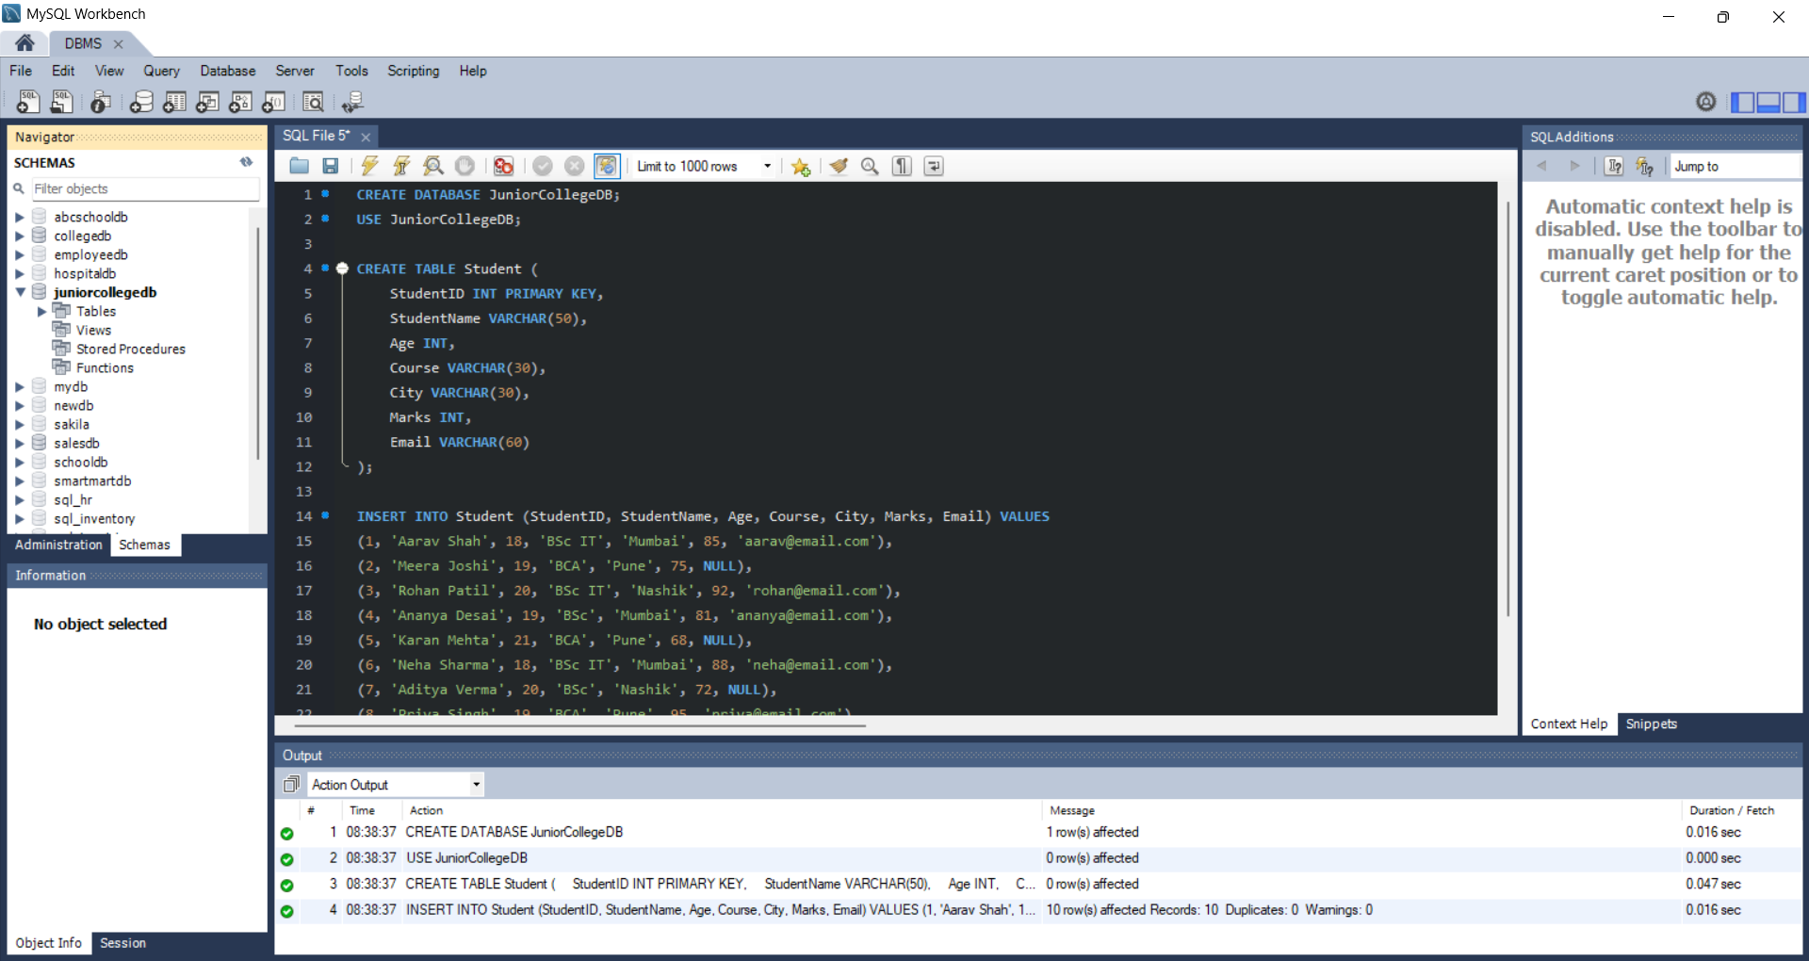

A.2
SELECT StudentID,StudentName,City,Marks
FROM student
WHERE City = 'Mumbai' AND Marks > 80;
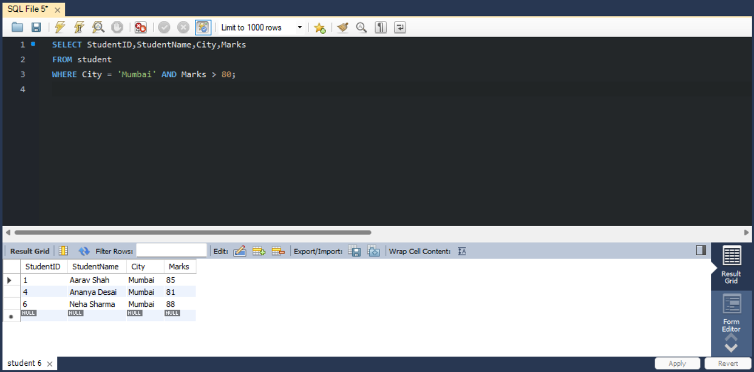

A.3
SELECT StudentName,Course,City
FROM Student
WHERE City = 'Pune' OR City = 'Nashik';
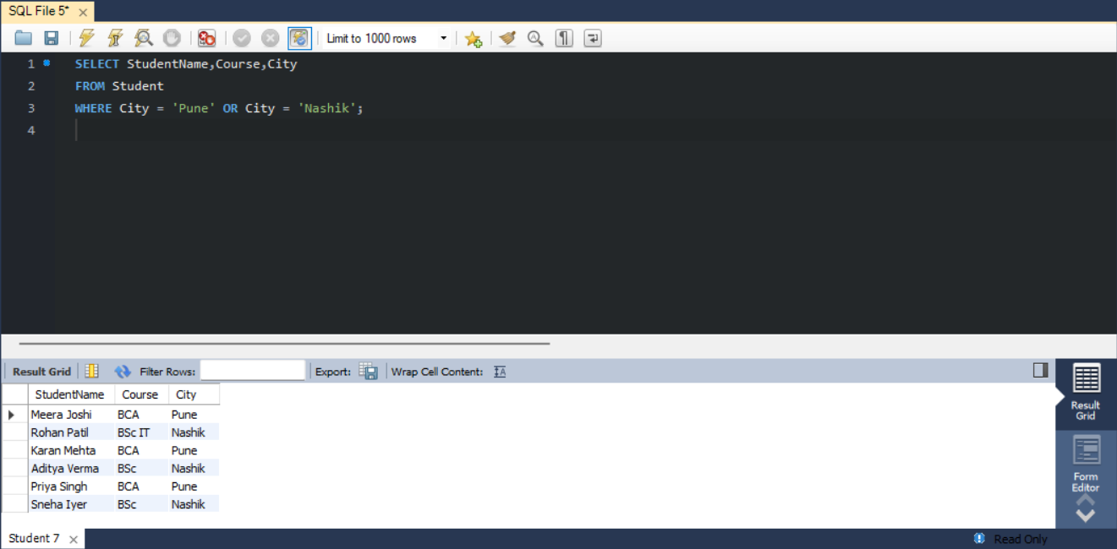
A.4
SELECT StudentName,Marks
FROM student
WHERE Marks BETWEEN 70 AND 90;
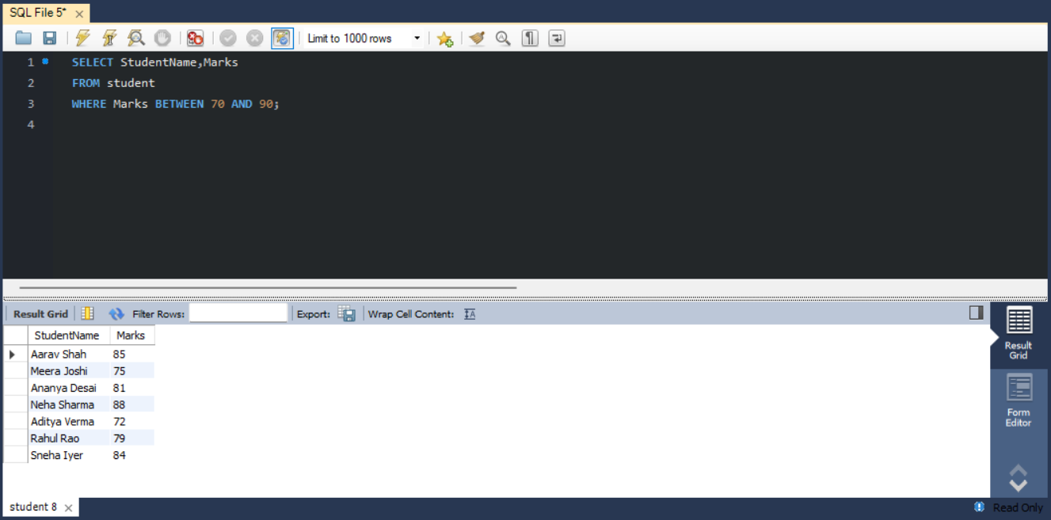

A.5
SELECT StudentID,StudentName
FROM Student
WHERE StudentName LIKE 'A%';
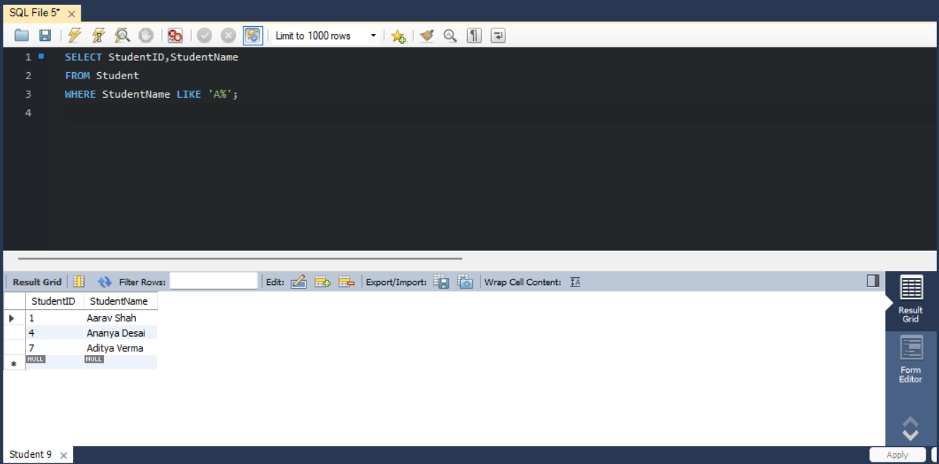

A.6
SELECT StudentID,StudentName,Email
FROM student
WHERE Email IS NULL;
